NAME | <*NAME1*> | DATE | <*DATE*>
 |  | AGE | <Age>
REF. BY | DR.<*Consultant/Gp1*> | SEX | <Sex>

RADIOGRAPHS OF KUB

Both kidneys and psoas shadows are fairly well visualized and appear normal.

There is no evidence of any abnormal calcific radiodensity in the region of kidneys, ureters and bladder.

No abnormality of the bowel gas pattern is noted.

The visualized bones in AP view are normal.

IMPRESSION:

- No significant abnormality detected.

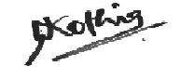
DR.NIKUNJ KOTHIA
CONS. RADIOLOGIST

